Possible cardiac benefits of combination of oral semaglutide and empagliflozin in treatment of type2 diabetic rats
Abstract:
Background: Throughout the last thirty years, the occurrence of diabetes has significantly risen in low- and middle-income countries. Diabetes is associated with both micro- and macrovascular complications. For numerous people with type 2 diabetes, the use several glucose-lowering treatments can be necessary to attain good glycemic control. Oral semaglutide is the 1st GLP-1RA accessible in tablet form, potentially enhancing management intensification had GLP-1RAs and giving an alternative for cases who prefer oral glucose-lowering treatment to attain superior glycemic control. Empagliflozin, a selective sodium-glucose cotransporter 2 inhibitor (SGLT2I), decreases hyperglycemia in cases had type 2 diabetes mellitus by diminishing renal glucose reabsorption and rising urinary glucose excretion. Aim of the study: The objective of the present research is to evaluate the possible benefits of the combination of oral empagliflozin and semaglutide in the management of type 2 diabetic rats and some of its associated CVS complications. Methods: Rats have been categorized into: Group 1: control normal group. Group 2: wasn’t managed diabetic (diseased group). Group 3: was managed with oral semaglutide. Group 4: was managed with empagliflozin. Group 5: was managed with oral semaglutide and empagliflozin. Treated groups received medications for four weeks. Results: Treated groups illustrated significant enhancement in almost all measured variables and the histopathology of the myocardium at the end of the fourth week of treatment. Conclusion: Our research demonstrated that the combined treatment by oral semaglutide and empagliflozin was superior to each drug alone in improving all parameters.
Key words: diabetes mellitus, micro- and macrovascular complications, oral semaglutide, empagliflozin.

1. Introduction

Diabetes mellitus is considered a worldwide health challenge because of its great occurrence (1). Throughout the last thirty years, the occurrence of diabetes has significantly risen in countries with low- and middle-income. The Eastern Mediterranean is one of the hot spots of diabetes, with approximately 13.7 percent of adults influenced (2).
Unluckily, the majority of cases have already developed vascular complications by the time they receive a diagnosis of Type 2 Diabetes Mellitus. Comorbidities like hypertension, obesity, as well as dyslipidaemia significantly elevate the risk of cardiovascular disease (CVD) in cases had Type 2 Diabetes Mellitus. nevertheless, unlike non-diabetic cases, those with Type 2 Diabetes Mellitus possess an elevated risk of CVD that is additional to and independent of conventional risk factors. (3).
The main aim of illness treatment in type 2 diabetes is to prevent or delay macrovascular and microvascular complications by achieving good glycemic control, facilitating weight reduction, and managing cardiovascular (CV) risk factors (4). Many persons had type 2 diabetes may necessitate treatment with numerous glucose-lowering medicines to achieve good glycemic control (5).
The rising occurrence of type 2 diabetes and its associated complications demonstrates the urgent necessity for effective management methods for this devastating illness has never been higher (6). One of the recently scrutinized families of antihyperglycemic medications regarding safety is the glucagon-like peptide-1 (GLP-1) receptor agonists (GLP-1RAs). These medicines are generated from the gut-derived incretin hormone GLP-1, that effectively trigger insulin secretion and suppresses glucagon release (7). GLP-1RA effectively lowers glucose levels by decreasing stomach emptying and hepatic gluconeogenesis (8). In addition to efficient glucose management, GLP-1RA therapy is correlated with diminutions in blood pressure and body weight (9). Oral semaglutide is the 1st glucagon-like peptide-1 receptor agonists accessible in tablet form, potentially enhancing management intensification with GLP-1RA and giving an alternative for cases who prefer oral glucose-lowering treatment to attain improved glycemic control (5).
Empagliflozin, a selective sodium-glucose cotransporter 2 inhibitor (SGLT2I), decreases hyperglycemia in cases with type 2 diabetes mellitus by diminishing renal glucose reabsorption and improving urinary glucose excretion (10). SGLT2 inhibitors additionally are utilized for the management of type I diabetes (11), obesity (12), atherosclerosis, myocardial infarction, heart failure, in addition to hypertension (13).
2. Aim of the work
- The objective of the current research is to evaluate the possible benefits of the combination of oral empagliflozin and semaglutide on experimentally induced type 2 diabetes and its associated complications like experimentally triggered myocardial infarction and experimentally triggered diabetic cardiomyopathy.
- In addition, the study will investigate the influence of the tested drugs on some parameters related to possible pathophysiological mechanisms such as, the level of LC III as a marker of autophagy, the level of caspase 3 and Bcl2 as markers of apoptosis and the concentration of malondialdehyde as a marker of oxidative stress.

3. Materials and method
3.1. Animals:
It is a prospective investigation performed on (40) Adult male albino mice weighing ranged from 150- 200 grams (at the initiating of the research), have been utilized for in-vivo experiments. They have been acclimatized for 1 week and have beencaged (eight rat per cage) in fully ventilated room at room temperature in the pharmacology department, Benha Faculty of Medicine. The investigation has been conducted from 1st of September 2023 to 7th of January 2024. Mice have been nourished a standard chow with water. This research has been permitted from ethical committee of Benha Faculty of Medicine {MD.11.2.2023}.
3.2. Drugs
Sucrose has been gained from El Nasr Pharmaceutical Chemicals Co. (ADWIC, Egypt). Streptozotocin and isoprenaline were purchased from Sigma-Aldrich (USA). Neutral buffered formalin solution (10%) was provided by El-Gomhoria Pharmaceutical Chemical Co. (Egypt). Oral semaglutide has been supplied by Novo Nordisk (Denmark), and empagliflozin has been gained from Eva Pharma (Egypt). Urethane (ethyl carbamate) was purchased from Prolabo (Paris, France), and heparin ampoules were gained from Novo Industry (Denmark).
3.3. Experimental groups and procedures:
The mice have been categorized into five equal groups (number=8) as follow;
- Control group(G1); formed of normal animals. They have been permitted standard water and normal diet. hey did not receive any medications.,
- Diseased group(G2); Non treated diabetic rats; Diabetes has been triggered via administration of high-fat and high sucrose diet for six weeks subsequently mice have been given intraperitoneal injection of a low dose of streptozotocin (STZ, thirty milligrams per kilogram body weight) (14) (15).
- Oral semaglutide treated diabetic group(G3); oral semaglutide has been administered by gastric gavage in a dose 0.6 milligrams per kilogram per day for four weeks (5, 16 and 17).
- Empagliflozin treated diabetic group(G4); empagliflozin has been taken via gastric gavage in a dose ten milligrams per kilogram per day for four weeks (18).
- Combined treated diabetic group(G5); oral semaglutide has been taken as group 3 and empagliflozin was separately administered as group 4.

HFD/STZ rat model is asuitable animal model for the last stage of type 2 diabetes. The rats in this model were suspected to have hyperglycemia, and cardiomyopathy.

The treated groups will receive medications for four weeks, after which myocardial infarction will be triggered in all diabetic groups via subcutaneous injection of isoprenaline (150 milligram per kilogram in the abdominal area, dissolved in two milliliters of saline. It has been injected as one dose (19).
One day before the end of experiment, all animals have been fasted overnight. At 8 am of the last day of the experiment, measurement of body weight and blood pressure was done, then induction of MI by isoprenaline was done. After that, Animals have been anesthetized with urethane at a dosage of 1.25 gram per kilograms body weight, with half injected intraperitonially for quick action and the other half subcutaneously for maintained action (20). Electrocardiogram recording has been performed two hours following injection of ISO.
Following the Electrocardiogram documenting, the chest has been quickly opened, and a blood sample has been gathered from the right ventricle prior to the heart's removal from the chest. Blood samples have been incubated at thirty-seven degrees Celsius until clotting, thereafter centrifuged at 3000 rpm for fifteen minutes to separate the serum, & stored at twenty degrees Celsius for biochemical analysis. The heart was removed, and the heart weight (HW) has been assessed; the atrial, vessels, epicardial adipose, in addition fibrous tissues have been cut and rinsed in cold saline. The right ventricular free wall has been cut along the septum, while the left ventricle, with the interventricular septum reserved, has been separate. The left ventricular mass (LVW) has been weighted. The heart weight index (hypertrophy index) has been measured using the formulas (LVW/BW) & (HW/BW). The heart tissue has been separated. Half was immediately rinsed with normal saline and preserved at -20 degrees Celsius for MDA evaluation. The remaining portion was preserved in formaldehyde for staining with hematoxylin and eosin for histopathological examination.
3.4.ECG Monitoring
The anesthetized rats have been placed supinely on a board, and electrocardiograms were continuously recorded using needle electrodes. The electrodes have been inserted subcutaneously in the rat's paw pads and related to an Electrocardiogram instrument. For every rat, Lead II has been documented as the most informative one (right forelimb to left hind limb). The Electrocardiogram tracing has been examined for Q, R, T waves, as well as heart rates.
3.5. Measurement of blood glucose:
By GOD-PAP enzymatic colorimetric technique (21)

3.6. Measurement of Serum Tropinin I activity:
Serum Tropinin-I activity has been measured by the Sandwich-ELISA principle (22).

3.7. Cardiac malondialdehyde (MDA) assay:
The antioxidant MDA kits have been utilized to evaluate the cardiac content as regards the enzymatic colorimetric assay technique (23).
3.8. Measurement of Rat NT-proBNP (N-Terminal Pro-Brain Natriuretic Peptide):
Rat NT-proBNP was measured by the Sandwich-ELISA principle (24).
3.9. Measurement of serum LCIII:
serum LCIII was measured by the Sandwich-ELISA principle.
3.10. Measurement of serum Bcl-2 and Caspase 3:
Bcl-2 and Caspase 3 have been assessed by the Sandwich-ELISA principle.

3.11. Histopathological examination of the cardiac tissue:
Transverse sections (two millimeters thickness) of the left ventricle free wall at the level of papillary muscle have been stained with H&E, followed by examination for mycocyte degenerative alterations & infarction-like necrosis (25).
3.12. Statistical analysis:
Statistical analyses have been carried out utilizing GraphPad prism software (version 10.3.1; GraphPad Software, San Diego, CA, United States of America). Information has been expressed as mean ± SD. One-way analysis of variance (ANOVA) followed by post hoc Tukey’s test analysis has been conducted for numerous comparisons. P-value not more than 0.05 has been deemed statistically significant.

4. Results
Induction of diabetes in mice by STZ and HFD led to significant rise in FBG, plasma insulin, HOMA-IR index, Total Cholesterol, Low-Density Lipoprotein, triglyceride and significant reduction in HDL. Also there was significant increase in SBP and MABP.
According to, the treated groups there was significant enhancement in FBG, plasma insulin, LDL, HOMA-IR index, triglycerides, total cholesterol, and significant rise in High-Density Lipoprotein concentration. (table 1)
Induction of diabetic cardiomyopathy by (HFD & STZ) and induction of acute myocardial infarction via isoprenaline resulted in significant increase in hypertrophy index {(HW/BW) &(LVW/BW)}, ST segment elevation, heart rate, serum concentration of pro BNP and serum troponin level. additionally, A significant deterioration has been observed in the histopathological examination of cardiac tissue.
According to, the treated groups a significant enhancement has been observed in hypertrophy index {(HW/BW) &(LVW/BW)}, ST segment elevation, heart rate, serum concentration of pro BNP and serum troponin level. (table 2). Additionally, there was significant enhancement in the histopathological examination of heart tissue in comparison with diseased group. (figure 2,3,4,5,6)
In addition, the diseased group exhibited significant rise in cardiac concentration of MDA, significant rise in the expression of apoptotic factor caspase-3, and significant diminution in antiapoptotic factor Bcl-2. Also, serum concentration of LC3-II (a marker of autophagy) was significantly decreased.
According to, the treated groups there was significant decrease in the level of caspase 3 and cardiac level of MDA, while the levels of Bcl-2 and LC3-II were significantly increased when in comparison with the diseased group. (table 3- figure 1)
The combined group was superior to each drug alone in emproving all parameters. Moreover, the variance among oral semaglutide and empagliflozin was insignificant in most of these variables.
Table (1): Effect of treatment with (oral semaglutide, empagliflozin and their combination) orally for 4 weeks on (FBG, FPI, HOMA-IR, LDL, triglycerides, HDL, total cholesterol, SBP and MABP) on experimentally induced diabetes by HFD and STZ in male albino rats.
Groups  Parameters | Control group |  | Diabetic/infarcted group |  | oral semaglutide group |  | empagliflozin group |  | combined  group
Groups  Parameters | Mean | ±SD | Mean | ±SD | Mean | ±SD | Mean | ±SD | Mean | ±SD
Fasting blood glucose  milligrams per deciliter | 86.33  ±4.429 |  | 268.3  ±17.24  a |  | 159  ±4.583  ab |  | 176.7 ±3.055  ab |  | 131 ±6.557  abcd
Fasting plasma insulin  μU/l | 8.133  ±1.9 |  | 27  ±1.47  a |  | 19.47  ±0.6658  ab |  | 22.57  ±0.611  abc |  | 15.83  ±0.3512  abcd
HOMA-IR | 1.8  ±0.2207 |  | 17.85  ±1.115  a |  | 7.64  ±0.4133  ab |  | 9.837  ±0.09713  abc |  | 5.067  ±0.3215  abcd
Cholesterol (mg/dl) | 95.59±7.247 |  | 225.7±5.957  a |  | 170.6±3.851  ab |  | 170.8±5.857  ab |  | 149.4±3.126  abcd
LDL (mg/dl) | 49.6±2 |  | 183.4±5.945  a |  | 133±5.305  ab |  | 135.5±9.271  ab |  | 107.8±3.019  abcd
Triglyceride (mg/dl) | 107.6±4.301 |  | 222.8±7.157  a |  | 158.1±3.995  ab |  | 179.6± 4.483  abc |  | 140.3±1.583  abcd
HDL (mg/dl) | 43.77±1.162 |  | 27.08±2.21  a |  | 34.72±2.768  ab |  | 33.74±1.608  ab |  | 40.29±0.6099  bcd
SBP  mmHg | 127  ±6.245 |  | 177 ±4.583  a |  | 151 ±2.646  ab |  | 152.7 ±2.517  ab |  | 140.7 ±2.082  abd
MABP | 90  ±1.0 |  | 127.3 ±2.517  a |  | 110.3 ±4.726  ab |  | 111.7 ±3.055  ab |  | 98.33 ±3.512  bcd

Data was represented as means±SD.
a: Significant against control(G1). (P below 0.05)
b: Significant against diseased group(G2). (P below 0.05)
c: Significant against oral semaglutide group(G3). (P below 0.05)
d: Significant against empagliflozin group(G4). (P below 0.05)

Table (2): Effect of management with (oral semaglutide, empagliflozin & their combination) orally for 4 weeks on (STsegment elevation, HR, serum troponin, pro BNP in addition hypertrophy index {HW/BW &LVW/BW}) on experimentally induced diabetic cardiomyopathy by (HFD & STZ) and experimentally triggered myocardial infarction in diabetic mice.
Groups  Parameters | Control group |  | Diabetic/infarcted group |  | oral semaglutide group |  | empagliflozin group |  | combined  group
Groups  Parameters | Mean | ±SD | Mean | ±SD | Mean | ±SD | Mean | ±SD | Mean | ±SD
HR(b/min) | 307.33  ±2.517 |  | 531  ±13.53  a |  | 439.3 ±3.055  ab |  | 433.3 ±4.163  ab |  | 419.7  ± 6.807  abc
ST elevation (mm) | -  - |  | 4.033 ±0.208  a |  | 2.933 ±0.152  ab |  | 2.2 ±0.2  abc |  | 1.733 ±0.152  abcd
Troponin  (ng/ml) | 13.41±0.77 |  | 50.39± 2.36  a |  | 29.54± 0.418  ab |  | 31.3 ±0.66  ab |  | 20.56±1.46  abcd
Pro BNP (pg/ml) | 105.7±4.21 |  | 355.6±10.96  a |  | 258.1±7.107  ab |  | 215.9±7.87  abc |  | 153±8.108  abcd
HWmg/BWgm | 2.823±  0.0152 |  | 4.107±  0.0901  a |  | 3.78±  0.131  ab |  | 3.44±  0.045  abc |  | 3.047±  0.1501  bcd
LVWmg/BWgm | 1.494±  0.052 |  | 2.153±  0.0503  a |  | 2.093±  0.0115  a |  | 1.913±  0.037  abc |  | 1.813±  0.045  abc

Table (3): Effect of treatment with (oral semaglutide, empagliflozin and their combination) orally for 4 weeks on (caspase3, BCL2, LC3-II and MDA) on experimentally induced diabetes by HFD and STZ in male albino rats.
Groups  Parameters | Control group |  | Diabetic/infarcted group |  | oral semaglutide group |  | empagliflozin group |  | combined  group
Groups  Parameters | Mean | ±SD | Mean | ±SD | Mean | ±SD | Mean | ±SD | Mean | ±SD
Caspase3 (pMol/L) | 14.94  ±0.8272 |  | 43.3  ±0.8  a |  | 29.47±1.172  ab |  | 31.23 ±0.7391  ab |  | 21.33  ± 1.165  abcd
BCL2 (ng/ml) | 1.707 ±0.106 |  | 0.46 ±0.0458  a |  | 0.846 ±0.0513  ab |  | 0.8 ±0.0458  ab |  | 1.053 ±0.1305  abd
LC3-II (pg/ml) | 166.5±1.934 |  | 74.93± 7.626  a |  | 117.6± 3.792  ab |  | 100.8 ±3.997  abc |  | 136.5 ±4.49  abcd
MDA(nM/g tissue) | 27.81±3.105 |  | 84.11±2.94  a |  | 55.76±3.738  ab |  | 57.1±4.028  ab |  | 44.62±3.325  abcd

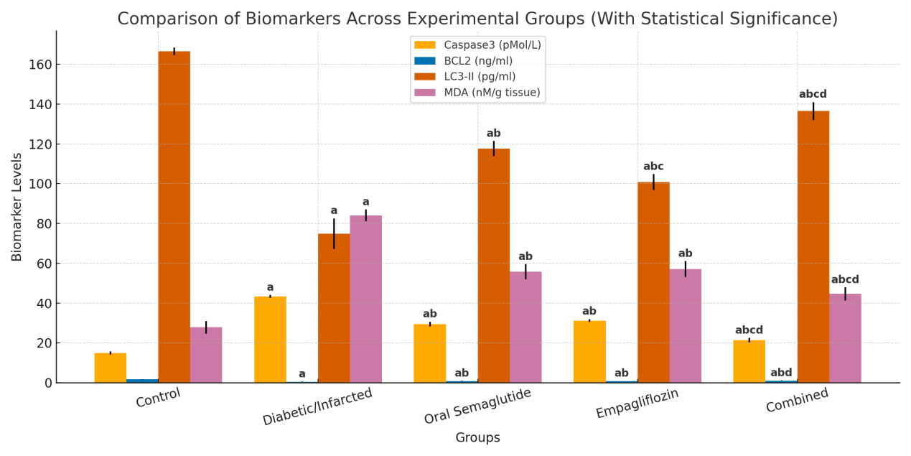 Figure.1: Graphical presentation showing effect of oral semaglutide, empagliflozin and their combination on serum concentration of caspase3, BCL2, LC3-II&MDA.

Histopathological changes:

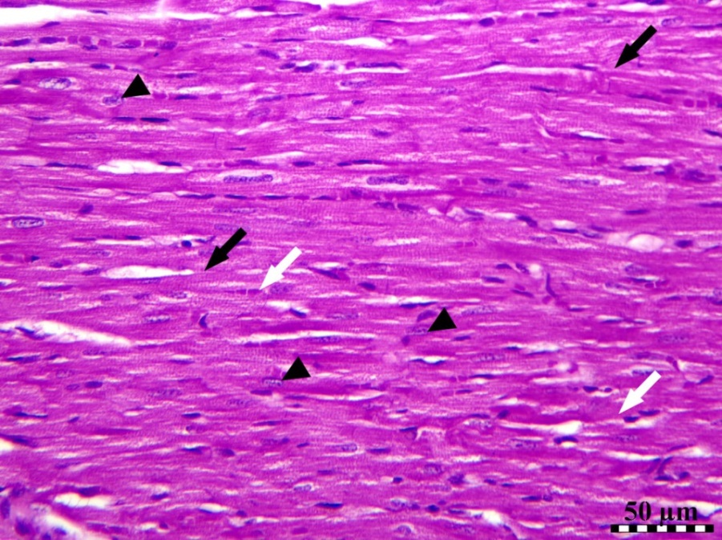

Fig. 2: photomicrograph of cardiac muscles of G1 illustrating normal architecture of cardiac muscles with branching cardiac fibers (black arrows), with oval centrally situated nuclei (black arrow heads), as well as cardiac blood vessels (white arrow). Hematoxylin and Eosin stain, Bar equal fifty micrometers.
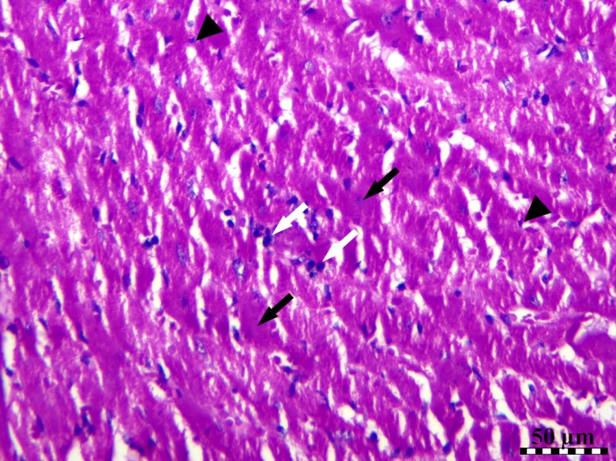

Fig. 3: photomicrograph of cardiac muscles of diabetic group illustrating disorganized cardiac muscles with necrosis of cardiac muscle fibers (black arrows), and nuclear pyknosis (black arrow heads) and small aggregation of mononuclear cells (white arrows). Stain H&E, Bar=50 µm.
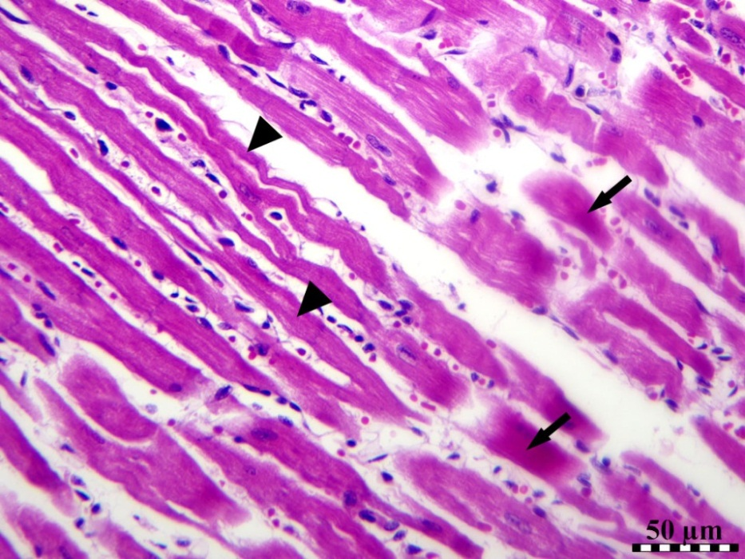

Fig. 4: photomicrograph of cardiac muscles of G3 illustrating shrinkage of cardiac muscle fibers (arrow heads) and necrosis of some cardiac muscle fibers (black arrows). Stain H&E, Bar equal fifty micrometers.

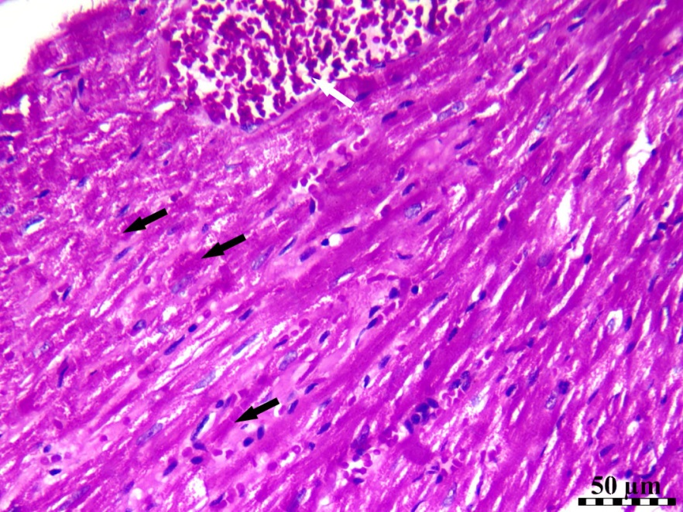

Fig. 5: photomicrograph of cardiac muscles of G4 demonstrating disorganized cardiac muscles with necrosis of some cardiac muscle fibers (black arrows), and congested cardiac blood vessels (white arrow). Stain H&E, Bar equal fifty micrometers.

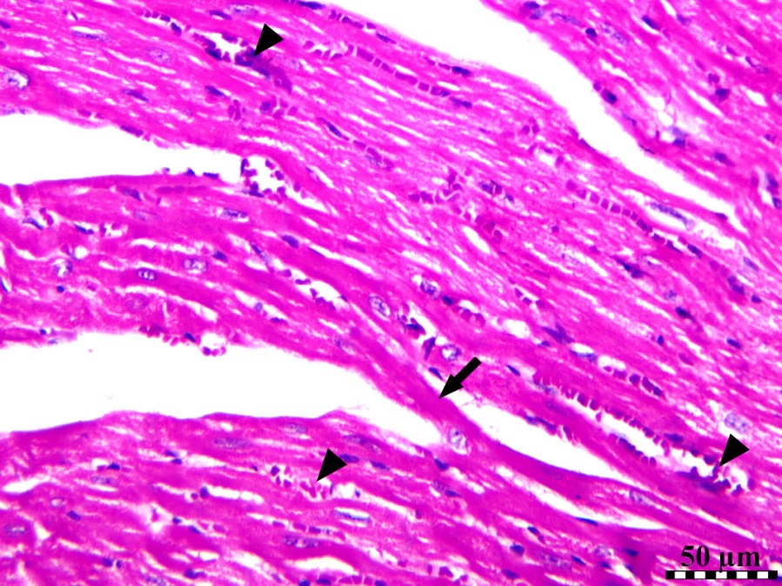

Fig. 6: photomicrograph of cardiac muscles of G5 demonstrating significant ameliorative effect with necrosis of few numbers of cardiac muscle fibers (black arrows) & mild congestion of cardiac blood vessels (arrow heads). Hematoxylin and Eosin stain, Bar equal fifty micrometers.

5.Discussion
This investigation aimed to investigate the combined therapeutic influences of oral semaglutide and empagliflozin in a rat model of type 2 diabetes and isoprenaline-triggered myocardial infarction. The combination therapy significantly improved glycemic control, lipid profile, blood pressure, and insulin resistance parameters compared to monotherapy. These results are in line with prior investigations reporting the efficacy of both agents in managing metabolic and cardiovascular complications.
In supporting with our findings, the research of Vernstrøm et al. (2024) (26) who examined the efficacy of separate and combined influences of empagliflozin and semaglutide on vascular function, reported that, combination management raised glycaemic time in range without raising the possibility of hypoglycaemia. Moreover, Radlinger et al. (2023) (27) reported that empagliflozin avoided hyperglycaemia as well as the accompanying hyperinsulinaemia, as a result of that it protects mice from diet-induced insulin resistance, weight gain in addition hepatic steatosis.
Also, these outcomes were in accordance with the study of Niu et al, (2022) (28) who stated that TCHO, LDL, TG, in addition pro-inflammatory factors were significantly decreased following semaglutide. Moreover, the study of Nasiri-Ansari et al, (2021) (29) reported that empagliflozin management led to significantly diminished total cholesterol, fasting glucose, in addition to triglyceride serum concentrations in high fat diet fed mice.
Diabetic cardiomyopathy (DCM) is mostly results from impaired metabolism of lipid and glucose and is independent of myocardial damage results from coronary heart disease, hypertension, valvular heart disease, in addition to other CVD (30). The development of DCM is influenced by metabolic disorders that adapted cardiac structural and functional adaptability, resulting in fibrotic diastolic dysfunction, cardiac remodeling, myocardial hypertrophy, in addition diminished ejection fraction in diabetic cases, potentially advancing to heart failure (31).
Both drugs, particularly in combination, reduced hypertrophy index, serum troponin, and pro-BNP levels, and improved ECG changes and myocardial histology, suggesting cardioprotective effects. These outcomes are in line with earlier reports highlighting the anti-fibrotic and remodeling benefits of empagliflozin and semaglutide in heart failure and myocardial injury models.
These outcomes are in agreement with Li et al. (2021) and Wang et al. (2024) (32,33) who studied the effect of empagliflozin on heart failure, reported that treatment by empagliflozin significantly reduced NT-proBNP, in histological analysis, empagliflozin significantly attenuated cardiac fibrosis in both ventricular & atrial tissues and significantly attenuated adverse left ventricle remodeling and so it can enhance cardiac function in mice had chronic heart failure. Also, the research of von Lewinski et al. (2022) (34) who examined the influence of empagliflozin in acute myocardial infarction, reported that empagliflozin has been correlated with a significantly higher NT-proBNP decrease, accompanied by a significant enhancement in echocardiographic structural and functional variables.
Empagliflozin was illustrated to enhance cardiac fibrosis in numerous HF experimental models (35). Chung et al.(2023) (36) reported that empagliflozin interrupted Ca²⁺ homeostasis via inhibiting NHE activity in human atrial fibroblasts, thereby diminishing their pro-fibrotic cellular activities.

Moreover, our outcomes are in agreement with the research of Li et al. (2024) (37) who stated that semaglutide significantly decreased serum brain natriuretic peptide (BNP) concentration and it also markedly decreased infarct size in myocardial I/R rats. Liu et al. (2022) (38) who studied the protective influence of glucagon-like peptide-1 on myocardial injury in mice had diabetic cardiomyopathy, reported that semaglutide significantly reduced the Hw/Bw in rats with diabetic cardiomyopathy.
semaglutide significantly diminished body weight, that is a key aspect of its pharmacological influences. As regards the investigation of Pan et al. (2022) (39), TNF-α, semaglutide reduced lipid, ROS, IL-6, as well as MDA concentrations in obese mice.So semaglutide can protect the heart via diminishing lipid peroxidation and lipid synthesis.
Diabetic cases frequently exhibit aberrant free radical generation & weakened antioxidative defenses, making them greatly susceptible to oxidative stress. This may subsequently trigger and promote diabetes complications. Consequently, applying antidiabetic medicines with antioxidative properties may provide dual advantages via addressing hyperglycemia and diminishing oxidative damage (40).
Furthermore, the combination therapy exerted antioxidant and anti-apoptotic effects, evidenced by reduced cardiac MDA and caspase-3 levels, along with increased Bcl-2 and LC3-II levels, indicating enhanced autophagy. These mechanisms align with the literature, which associates both drugs with reduced oxidative stress and apoptosis via modulation of key molecular pathways.
In supporting of our findings Yang et al. (2019) and Zhu et al. (2023) (41,42) founded that semaglutide up-regulate Bcl-2, and down-regulate Caspase-3, and so it inhibits ischemia/reperfusion-induced cardiomyocyte apoptosis. Furthermore,these outcomes are in accordance with the research of Chang et al. (2020) (43) who stated that semaglutide enhanced autophagy by rising the expression of LC3II, further they illustrated that semaglutide inhibited apoptosis by rising the expression of Bcl2 and inhibiting the expression of Bax.
The metabolic enzyme Acyl-CoA oxidase 1 (ACOX1), a key rate-limiting enzyme in fatty a` β-oxidation, is expressed across several tissues. Throughout the β-oxidation of long-chain fatty a`, Acyl-CoA oxidase 1 produces H₂O₂ as a byproduct. An excessive buildup of H₂O₂ may led to oxidative stress within cells (44). The study of Yang et al. (2025) (44) explained the role of semaglutide in the hippocampus &its capability to alleviate cognitive impairments. decrease oxidative stress through regulating ACOX1. Also, they found that the level of MDA was significantly decreased. Moreover, Yang et al. (2024) (45) found that there was a notable diminution in the concentrations of Interleukin-6, ROS, MDA, TNF-α, Interleukin-1 beta, T-SOD, in addition adenosine in myocardial tissue, and reported that semaglutide decreases cardiomyocyte damage attributed to high-fat.

Also, Nasiri-Ansari et al, (2021) (29) who studied the effect of empagliflozin on NAFLD it’s referred to Non-Alcoholic Fatty Liver Disease in High Fat Diet Fed ApoE^{(-/-)} Mice, reported that empagliflozin activate autophagy, reduce ER stress and apoptosis via increasing LC3B expression, increasing the Bcl2/Bax ratio, inhibiting CASPASE-8 cleavage and diminishing liver cell apoptosis.
Srour et al. (2024) (46), Research on the evolving role of SGLT-2 inhibitors and GLP-1 receptor agonists in managing cardiovascular injury caused by obesity indicated that empagliflozin significantly decreased markers of oxidative stress, including malondialdehyde (MDA), lipid hydroperoxide, superoxide dismutase (SOD), in addition glutathione peroxidase (GSH-Px), in tissue from diabetic mice.
Overall, the current findings support the potential of combining oral semaglutide and empagliflozin as a promising approach to mitigate diabetic cardiomyopathy and related complications through metabolic correction and direct cardiac protection.

Conclusion
Our study revealed that the combined treatment by oral semaglutide and empagliflozin was superior to each drug alone in improving all measured parameters and improving the histopathology of the myocardium., this can be because of their synergestic antioxidant effect, anti-apoptotic effect, enhancement of autophagy, glycemic control in addition to improvement of dyslepidemia.
References
- Rydén L, Grant P, Anker S, Berne C, Cosentino F. ESC Guidelines on diabetes, pre-diabetes, and cardiovascular diseases developed in collaboration with the EASD. Eur Heart J. 2013;34:3035–87.
- DeFronzo RA. From the triumvirate to the ominous octet: a new paradigm for the treatment of type 2 diabetes mellitus. Diabetes. 2009;58:773–95.
- Davies MJ, D'Alessio DA, Fradkin J, et al. Management of hyperglycemia in type 2 diabetes, 2018. Diabetes Care. 2018;41(12):2669–701.
- Andersen A, Knop FK, Vilsbøll T. A pharmacological and clinical overview of oral semaglutide. Drugs. 2021;81(9):1003–30.
- Smits MM, van Raalte DH. Safety of semaglutide. Front Endocrinol (Lausanne). 2021;12:645563.
- Holst JJ. The physiology of glucagon-like peptide 1. Physiol Rev. 2007;87:1409–39.
- Smits MM, Tonneijck L, Muskiet MH, et al. Gastrointestinal actions of GLP-1 based therapies. Diabetes Obes Metab. 2016;18:178–85.
- Boye KS, Ross M, Mody R, et al. Patients’ preferences for oral vs injectable diabetes medications. Diabetes Obes Metab. 2020.
- Hussein H, Zaccardi F, Khunti K, et al. Efficacy and tolerability of SGLT2 inhibitors and GLP-1 RAs. Diabetes Obes Metab. 2020;22:1035–46.
- Lamos EM, Younk LM, Davis SN. Empagliflozin in type 1 diabetes. Expert Opin Investig Drugs. 2014;23:875–82.
- Neeland IJ, Rocha ND, Hughes C, et al. Empagliflozin and hepatic gluconeogenesis. Obesity (Silver Spring). 2020;28:1254–62.
- Pabel S, Wagner S, Bollenberg H, et al. Empagliflozin improves diastolic function. Eur J Heart Fail. 2018;20:1690–700.
- Deng X, Zhang C, Wang P, et al. Cardiovascular benefits of empagliflozin. J Clin Endocrinol Metab. 2022;107(7):1888–96.
- Zhang M, Zhang H, Liu C, et al. Myocardial protective effects of nicorandil. Med Sci Monit Basic Res. 2018;24:141–45.
- Heather LC, Hafstad AD, Halade GV, et al. Guidelines on models of diabetic heart disease. Am J Physiol Heart Circ Physiol. 2022;323(1):H176–H200.
- Nair AB, Jacob S. A simple practice guide for dose conversion. J Basic Clin Pharm. 2016;7(2):27–31.
- Yabe D, Nakamura J, Kaneto H, et al. PIONEER 10 study of semaglutide. Lancet Diabetes Endocrinol. 2020;8(5):392–406.
- Trang NN, Chung CC, Lee TI, et al. Empagliflozin and liraglutide in DCM. Int J Mol Sci. 2021;22(3):1177.
- Nirmala C, Puvanakrishnan R. Isoproterenol-induced MI in rats. Med Sci Res. 1994;22:575–77.
- Date Y, Nakazato M, Murakami N, et al. Ghrelin and gastric acid secretion. Biochem Biophys Res Commun. 2001;280(3):904–07.
- Burrin JM, Price CP. Measurement of blood glucose. Ann Clin Biochem. 1985;22:327–42.
- Albadrani GM, BinMowyna MN, Bin-Jumah MN, El–Akabawy G, Aldera H, Al-Farga AM. Quercetin prevents myocardial infarction adverse remodeling in rats by attenuating TGF-β1/Smad3 signaling: Different mechanisms of action. Saudi J Biol Sci. 2021;28(5):2772–82.
- Ohkawa H, Ohishi N, Yagi K. Assay for lipid peroxides in animal tissues by thiobarbituric acid reaction. Anal Biochem. 1979;95(2):351–58.
- Ouyang Q, Xu R, Lin Q, Yan J, Zhang L, Zhao H. Multimodal ultrasound imaging of a rat model with ischemic heart failure and its relationship to histopathology. Am J Transl Res. 2024;16(9):4589.
- Fischer AH, Jacobson KA, Rose J, Zeller R. Hematoxylin and eosin staining of tissue and cell sections. Cold Spring Harb Protoc. 2008;2008(5):pdb-prot4986.
- Vernstrøm L, Gullaksen S, Sørensen SS, Funck KL, Laugesen E, Poulsen PL. Separate and combined effects of empagliflozin and semaglutide on vascular function: A 32‐week randomized trial. Diabetes Obes Metab. 2024;26(5):1624–35.
- Radlinger B, Ress C, Folie S, et al. Empagliflozin protects mice against diet-induced obesity, insulin resistance and hepatic steatosis. Diabetologia. 2023;66:754–67.
- Niu S, Chen S, Chen X, Ren Q, Yue L, Pan X, Zhao H, Li Z, Chen X. Semaglutide ameliorates metabolism and hepatic outcomes in an NAFLD mouse model. Front Endocrinol (Lausanne). 2022;13:1046130.
- Nasiri-Ansari N, Nikolopoulou C, Papoutsi K, Kyrou I, Mantzoros CS, Kyriakopoulos G, et al. Empagliflozin attenuates non-alcoholic fatty liver disease (NAFLD) in high fat diet-fed ApoE(-/-) mice by activating autophagy and reducing ER stress and apoptosis. Int J Mol Sci. 2021;22(2):818.
- Wen W, Cao Y, Chen P, Li J, Li W, Huang G, et al. A reliable strategy for establishment of an animal model of diabetic cardiomyopathy: Induction by a high-fat diet combined with single or multiple injections of low-dose streptozotocin. Life Sci. 2024;358:123161.Gong, W., N. Zhang, X. Sun, Y. Zhang, Y. Wang, D. Lv, et al. 2024. "Cardioprotective effects of polydatin against myocardial injury in HFD/stz and high glucose-induced diabetes via a Caveolin 1-dependent mechanism." Phytomedicine 135: 156055.
- Gong W, Zhang N, Sun X, Zhang Y, Wang Y, Lv D, et al. Cardioprotective effects of polydatin against myocardial injury in HFD/stz and high glucose-induced diabetes via a Caveolin 1-dependent mechanism. Phytomedicine. 2024;135:156055.
- Li X, Lu Q, Qiu Y, do Carmo JM, Wang Z, da Silva AA, et al. Direct cardiac actions of the sodium glucose co-transporter 2 inhibitor empagliflozin improve myocardial oxidative phosphorylation and attenuate pressure-overload heart failure. J Am Heart Assoc. 2021;10(6):e018298.
- Wang Z, Liu Q, Wang X, Wang P, Wang Z, Zhang F. Empagliflozin improves cardiac function in rats with chronic heart failure. Naunyn Schmiedebergs Arch Pharmacol. 2024;397(2):1037–44.
- von Lewinski D, Kolesnik E, Tripolt NJ, Pferschy PN, Benedikt M, Wallner M, et al. Empagliflozin in acute myocardial infarction: the EMMY trial. Eur Heart J. 2022;43(41):4421–32.
- Santos-Gallego CG, Requena-Ibanez JA, San Antonio R, Garcia-Ropero A, Ishikawa K, Watanabe S, et al. Empagliflozin ameliorates diastolic dysfunction and left ventricular fibrosis/stiffness in nondiabetic heart failure: A multimodality study. JACC Cardiovasc Imaging. 2021;14(2):393–407.
- Chung CC, Lin YK, Chen YC, Kao YH, Yeh YH, Trang NN, Chen YJ. Empagliflozin suppressed cardiac fibrogenesis through sodium-hydrogen exchanger inhibition and modulation of calcium homeostasis. Cardiovasc Diabetol. 2023;22(1):27.
- Li X, Luo W, Tang Y, Wu J, Zhang J, Chen S, et al. Semaglutide attenuates doxorubicin-induced cardiotoxicity by ameliorating BNIP3-mediated mitochondrial dysfunction. Redox Biol. 2024;72:103129.
- Liu Y, Chen L, Wu H, Zhang H. Protective effect of glucagon-like peptide-1 mediated by ultrasound microbubbles on myocardial injury in rats with diabetic cardiomyopathy. Bioengineered (Oak Ridge). 2022;13(2):3251–61.
- Pan X, Yue L, Ban J, Ren L, Chen S. Effects of semaglutide on cardiac protein expression and cardiac function of obese mice. J Inflamm Res. 2022;15:6409–25.
- Yaribeygi H, Maleki M, Foroozanmehr B, Kesharwani P, Jamialahmadi T, Karav S, Sahebkar A. Exploring the antioxidant properties of semaglutide: A comprehensive review. J Diabetes Complications. 2024;108906.
- Yang X, Feng P, Zhang X, Li D, Wang R, Ji C, et al. The diabetes drug semaglutide reduces infarct size, inflammation, and apoptosis, and normalizes neurogenesis in a rat model of stroke. Neuropharmacology. 2019;158:107748.
- Zhu R, Chen S. Proteomic analysis reveals semaglutide impacts lipogenic protein expression in epididymal adipose tissue of obese mice. Front Endocrinol (Lausanne). 2023;14:1095432.
- Chang YF, Zhang D, Hu WM, Liu DX, Li L. Semaglutide-mediated protection against Aβ correlated with enhancement of autophagy and inhibition of apoptosis. J Clin Neurosci. 2020;81:234–39.
- Yang Y, Song L, Yu L, Zhang J, Zhang B. Transcriptomics and proteomics characterizing the antioxidant mechanisms of semaglutide in diabetic mice with cognitive impairment. Int J Mol Med. 2025;55(4):56.
- Yang L, Pan X, Pan Z, Gao H, Ban J, Chen S. Semaglutide reduces cardiomyocyte damage caused by high-fat through HSDL2. Drug Des Devel Ther. 2024;18:5501–15.
- Srour L, Ismail J, Njeim R, Eid AA. Exploring the evolving role of SGLT-2 inhibitors and GLP-1 receptor agonists in managing cardiovascular injury induced by obesity: Spotlight on ROS as a key mediator. In: Oxidative Stress in Cardiovascular-Metabolic Diseases. 2024. p. 207–26.

